Project Data Flow Diagram

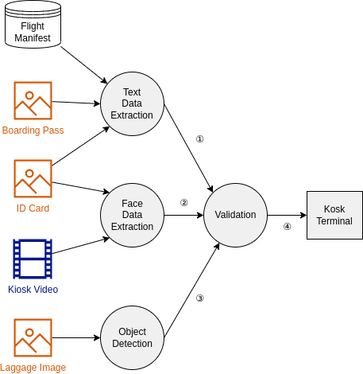

**Explaining Data Flow as shown in the above image:**

① Validation result by matching info between Boarding Pass, ID Card and

　 Flight Manifest.

② Validation result by matching face between ID Card and Kiosk Video.

③ Validation result if the lighter is in the luggage or not.

④ Messages to be displayed on the kiosk terminal based on all validation results.